**WELCOME TO DAY 1- AWS OVERVIEW**

1. Traditional computing
2. Cloud computing
3. Could computing benefits
4. Features of cloud computing
5. Cloud deployment model
6. Cloud services
7. VM
8. Container
9. Different CSP

Different CSP

AWS-

GCP

Azure

Day 1:

Introduction about AWS

Amazon EC2

Amazon storage

AWS

1. Public cloud provider
2. Subsidiary
3. Launched in 2006
4. Provides- 176 services – Compute, Strorage, Network ect
5. Global cloud infrastructure.

WHY AWS

1. More experiences – Reliability, Security, Performance
2. More functionality all other CSP
3. More features
4. New technologies

Global infrastructure

Infrastructure components:

AWS Wavelength:

AWS Local zone: Extended AWS region

Closer to IT center and residence area

Amazon EC2

1. Long process
2. Hardware knowledge
3. Static capacity

Developing the application

Server

EC2 – Elastic compute cloud

1. Scalable compute capacity
2. No hardware knowledge
3. No Hardware are required –
4. Faster deployment
5. Can launch as many instances as possible in different location
6. Firewalls – Firewall rule
7. Mange the storage

Things that we want to launch an instance: AWS account, Internet connection and a laptop

Features of EC2

1. AMI (amazon machine images)
2. Instance type
3. Tags
4. Keypairs
5. Security group
6. Amazon EBS
7. VPC
8. Elastic IP address

Creating an instance:

Login to your AWS account

Go to AWS Management console

Select services

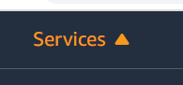

From services select compute

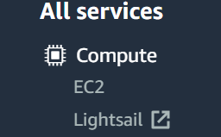

Select EC2

EC2 dashboard

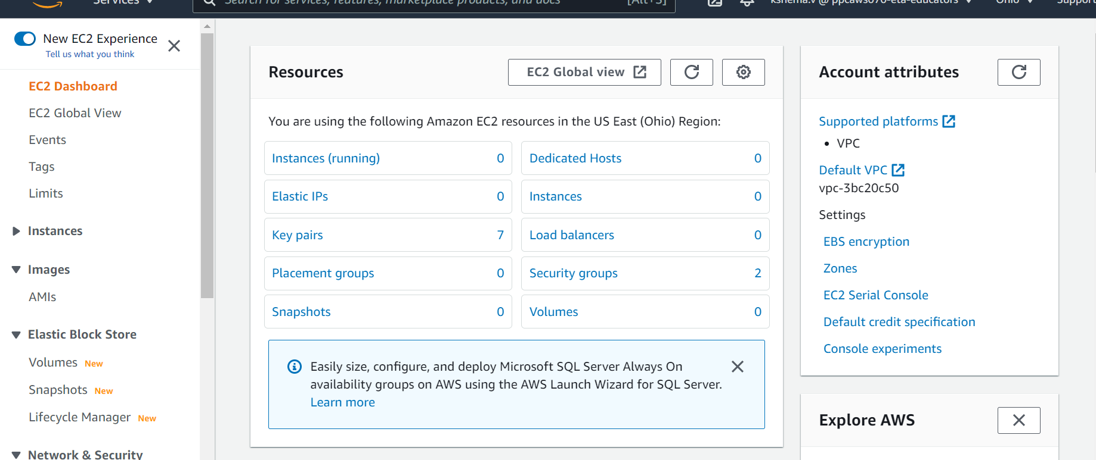

Select instances:

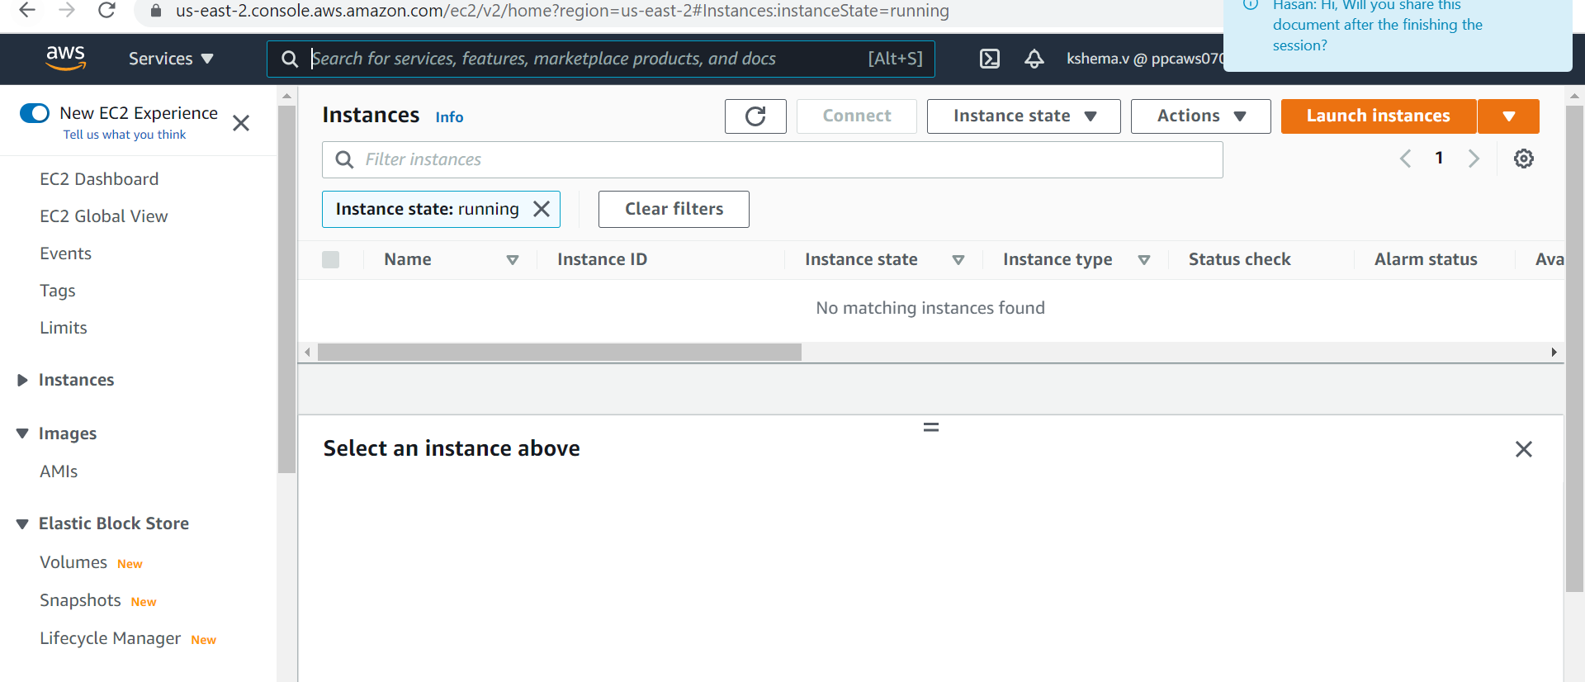

Click on launch instances

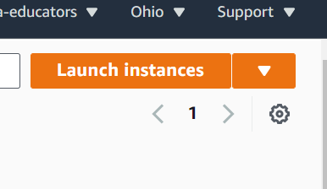

Step 1: Select the AMI

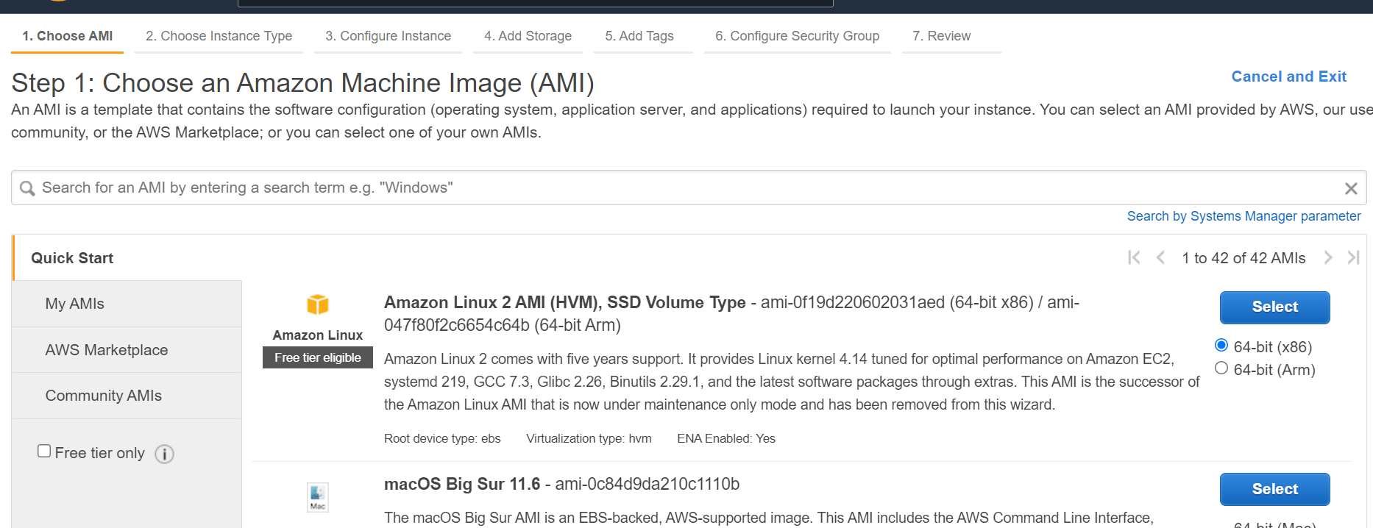

AMI: It is a template that defines the OS and the additional application needed for server

Published AMI

Custom AMI

AMI Name: **Amazon Linux 2 AMI (HVM), SSD Volume Type**

**Step 2: instance type**

1. General purpose
2. Compute optimized
3. Memory optimized
4. Accelerated computing
5. Storage optimized

General purpose: Provide a balance : compute , memory , network resourse

Compute optimized : Ideal for compute bound application that benefits for high performance processes

Eg: Dedicated gaming server

Memory optimized: Designed to deliver fast performance for workloads the process of large data set in memory

Accelerated computing: Used hardware accelerator or co-processor ,to perform functions like data pattern matching etc.

Storage Optimized: designed for workloads that require high sequential read and write to very large data set .

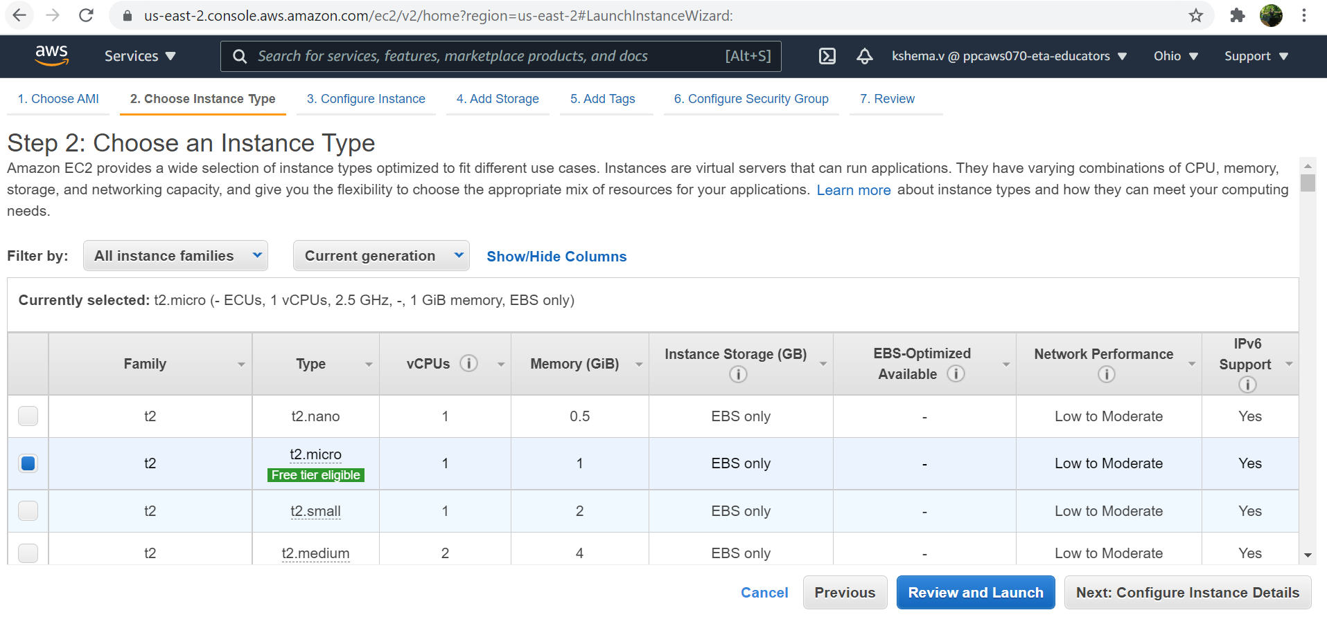

Step 3: Configure instance

VPC: A virtual network dedicated to your aws account.

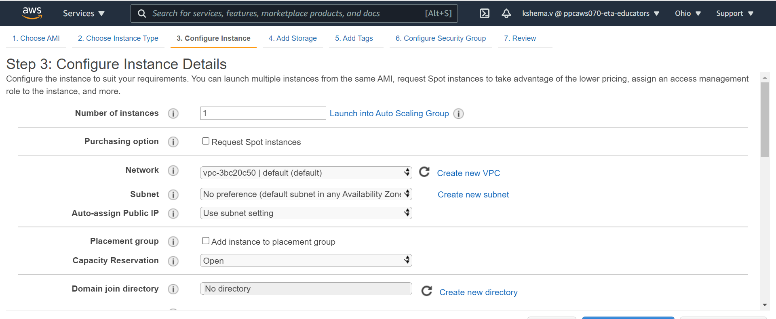

Step 4: Add storage

Instance storage: tempory storage

EBS: Elastic block storage

1. Provides a block level storage
2. If you want to retain a data it has to backuped
3. Backing up- EBS Snapshot – Only the change data is updated .

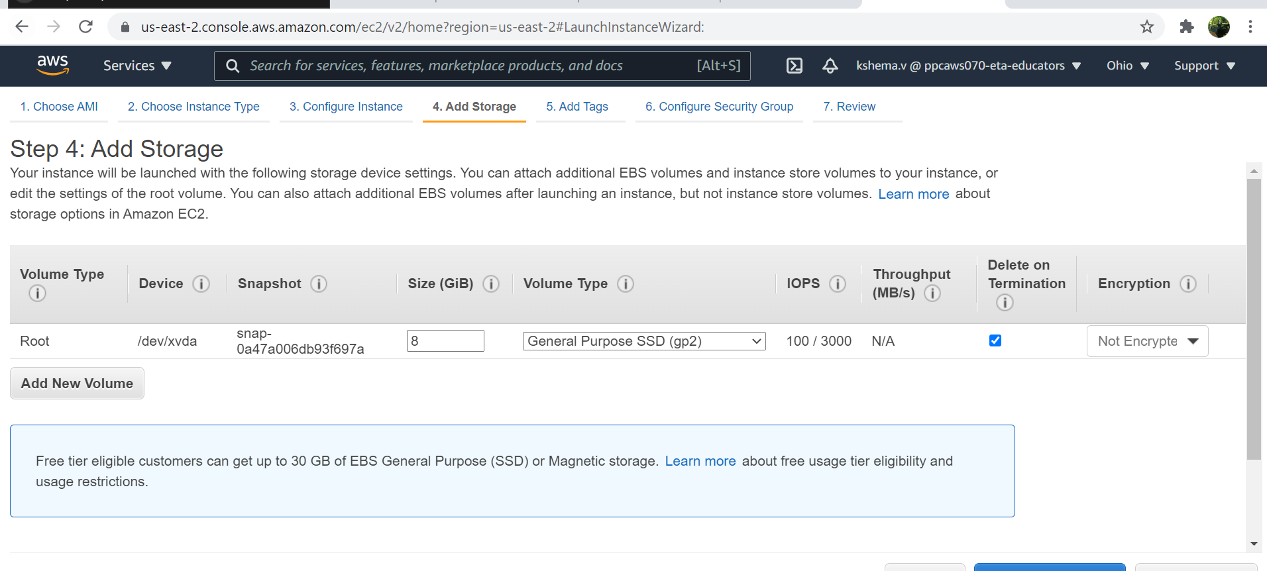

Tags:

Identifying our instances..

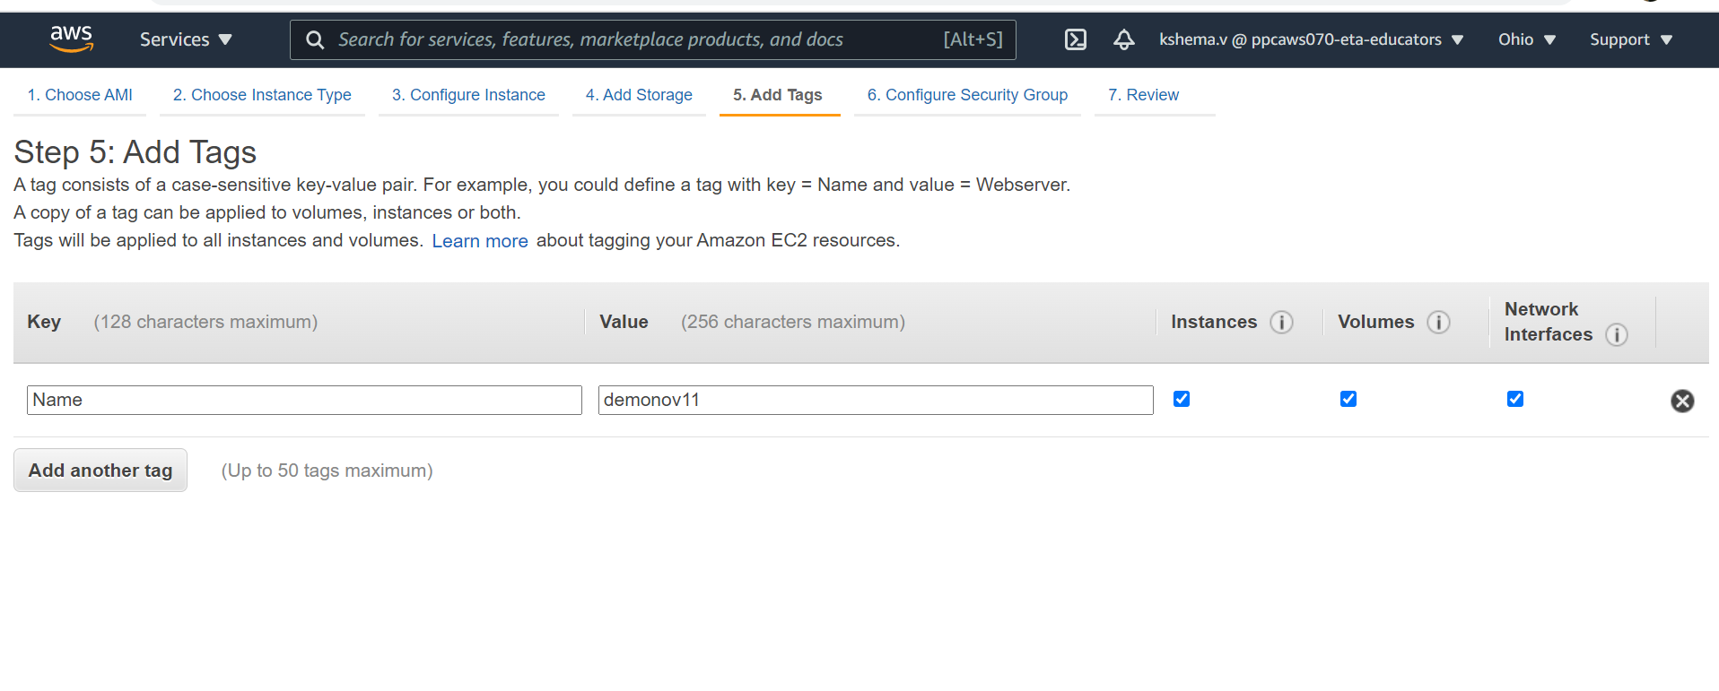

Step 6: Security group

1. Control the traffic.

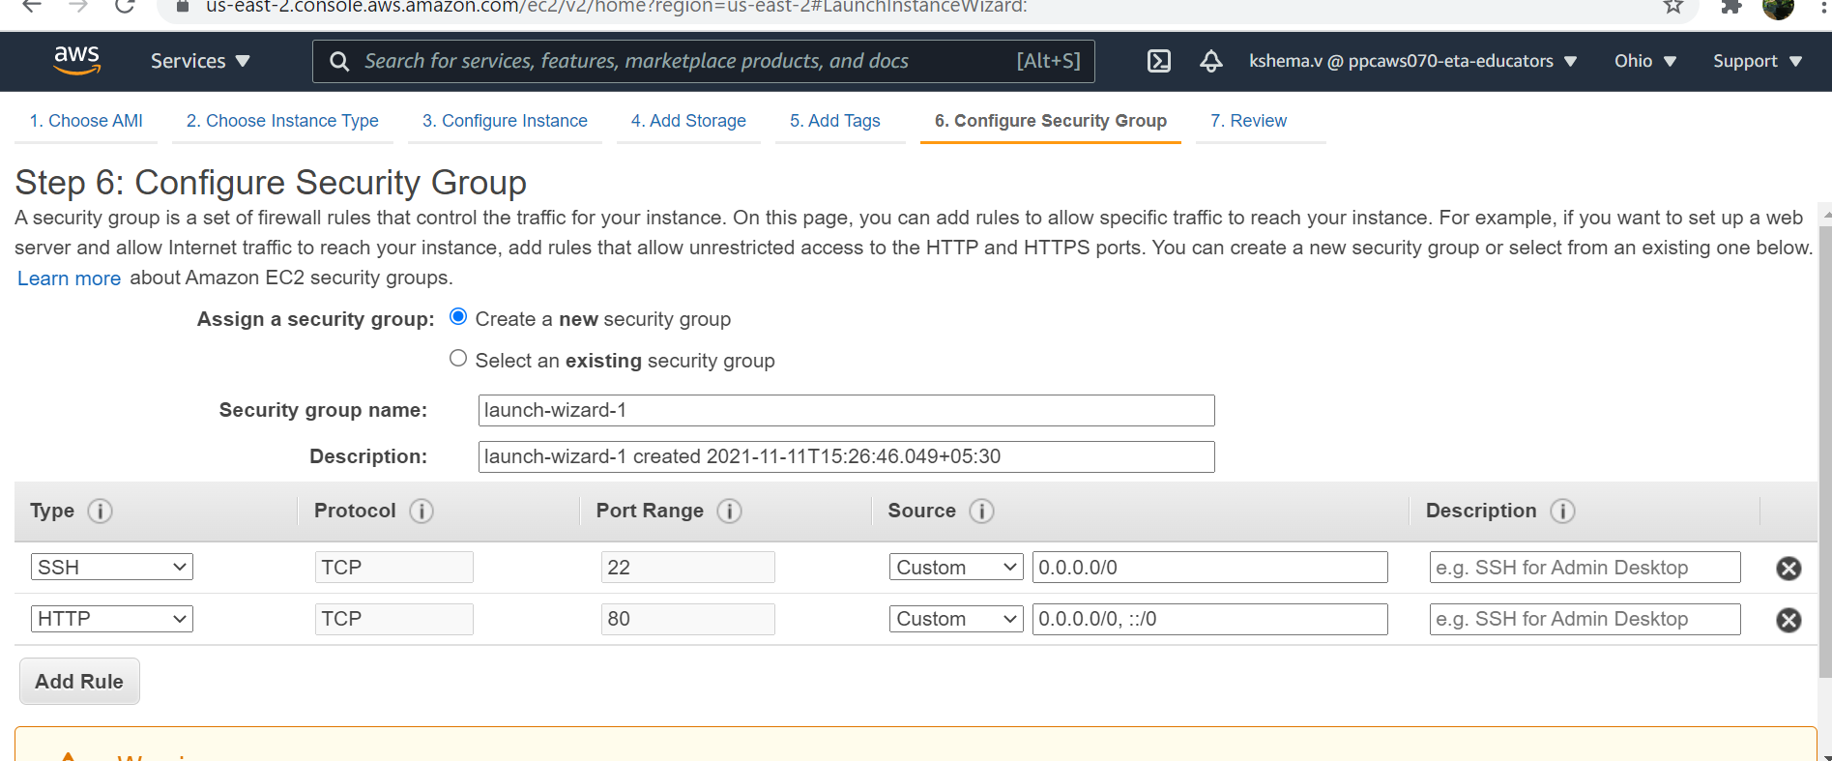

After all the 7 steps you can review the details you have entered and you can launch your instance

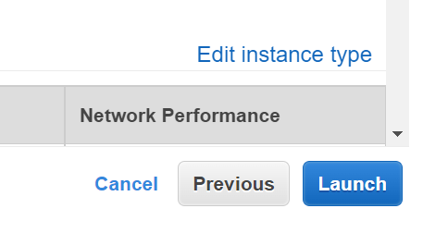

Key pair:

Private key : User have to keep , If it is lost we cannot reget it

Public key : AWS

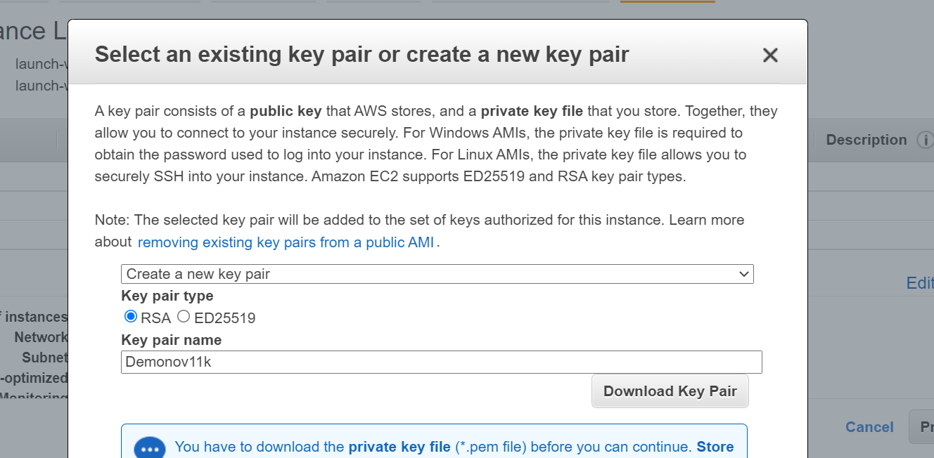

Click launch instance

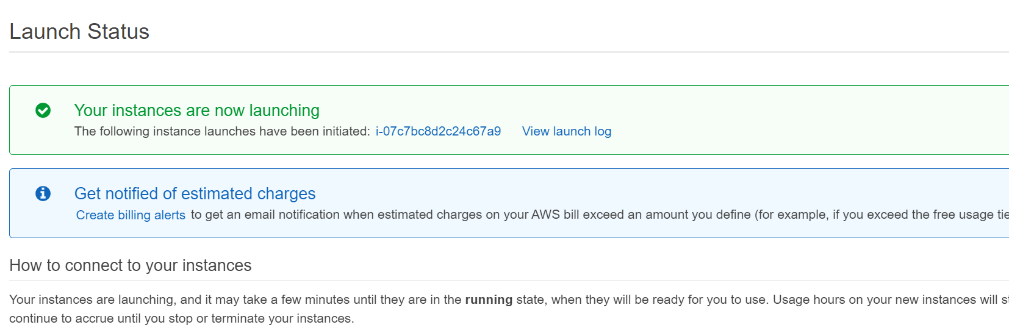

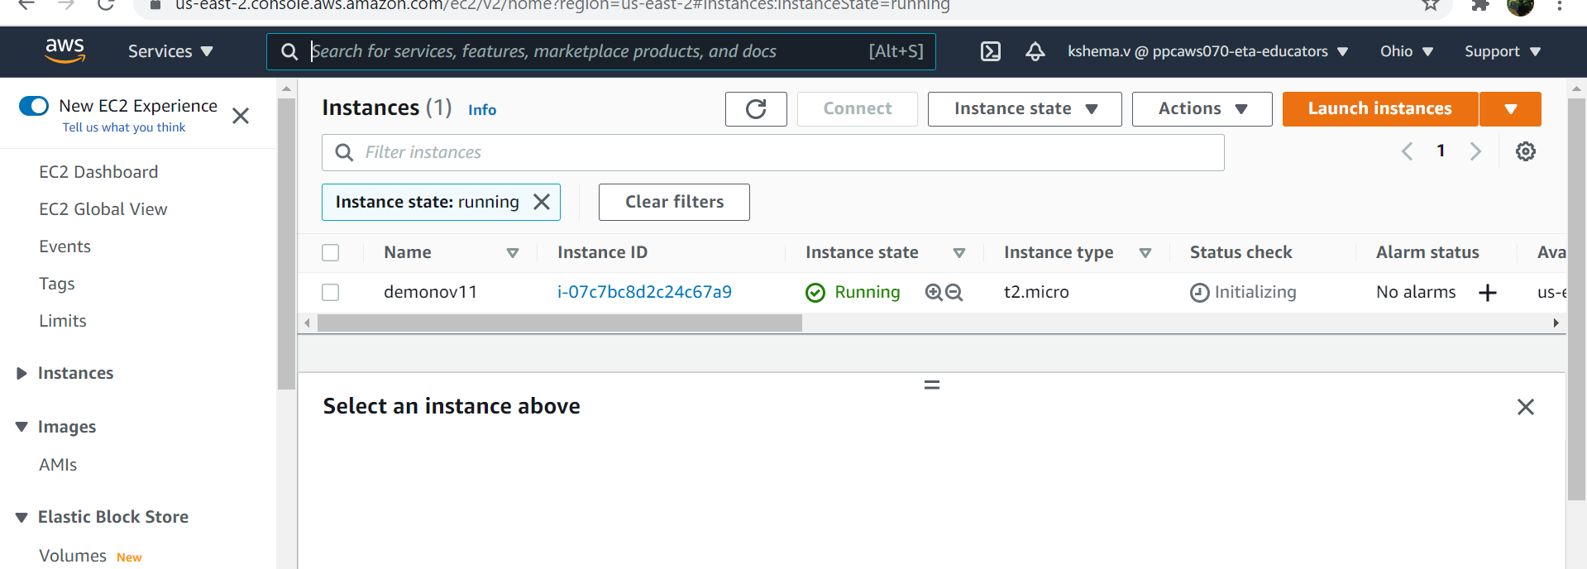

EC2: https://aws.amazon.com/ec2/instance-types/

WE HAVE TO TERMINATTE THE INSTACE AFTER THE NEED.

Amazon EC2 Pricing models

1. On Demand instances
2. Stop instances
3. Savings plan
4. Dedicated host.

On Demand instances: No longer Commitments

No upfront payment

Can increase or decrease the compute capacity according to the demand.

Recommend for:

1. Low cost and flexibility
2. Predict the workload cannot be predicted.
3. Dev and test

Spot Instances: Flexible start and end time.

Users who have urgent computing needs for large amount of addictional capacity

90% OFF – on demand

Dedicated HOST: Purchase the host privately

Savings plan: If you need instance for 1-3 year (Long term).

Reserved Instance: Reserving an instance for a particular time period.

**Amazon Elastic Beanstalk**

Buy a computer:

1. I can go to a warehouse and purchase the hardware
2. Go to a shop and purchase

Amazon EBS is a web application hosting platform.

Used for developing and scaling application.

Networkingà storageà serverà virtualizationàOSàMiddlewareàRuntimeàdataàApplication

EBS help you to deploy your application with more fun.

1. Quicker deployment
2. Simplifies the operation
3. Cost effective
4. Allow to share with security.
5. Fast way to deploy

**AWS Lambda**

1. **Serverless services**

S3

Server

DB

We will take a 3rd party library

No need of learning new thing

Code that you upload to lambda – lambda function

2 OPTION: Ether you can zip the code and upload

Or else you can you the management console to write the code.

**Amazon Storage**

**Amazon S3:** Amazon simple storage services.

Store à Distribute à Manage it

After n years I need x 40tb

1. Excess of storage
2. Shortage of storage

S3: Provides an object storage service that is – scalable, secure and available

The data are stored in buckets

Data that are stored as object

Metadata

Data

In S3 we can store any amount of data

Easy to use

Access control

Durability is 99.9999999

Features

1. Auto scale
2. Versioning of object:
3. Replicate copy of object: Multi availability zone
4. Pay as you use.
5. Different storage classes

Storage classes

1. S3 Standard
2. S3 Standard IA
3. S3 Intelligent Tiering
4. S3 one zone IA
5. S3 Glacier
6. S3 Glacier Deep archive